Download and Install MS SQL Server 2005

To use MS SQL Server and its database, one needs to download the server software and server management software. Fortunately, Microsoft provides a free version of SQL Server – MS SQL Server 2005 Express, which has the full functionality of the standard MS SQL Server.
One needs complete the following steps to finish this downloading and installation.

- Downloading and Installation

Go to Web site: http://msdn.microsoft.com/vstudio/express/sql/download/

Before you can install any member of the SQL Server 2005 Express Edition family, you must install the .NET Framework 2.0 and MSXML 6.0 Parser. Regularly, both components should have been installed in your computer if you have installed Visual Studio.NET 2008. Scroll down along this page and click the Download hyperlink to download SQL Server 2005 Express Edition. Click the Save button to save this file into the Temp folder in our root drive.

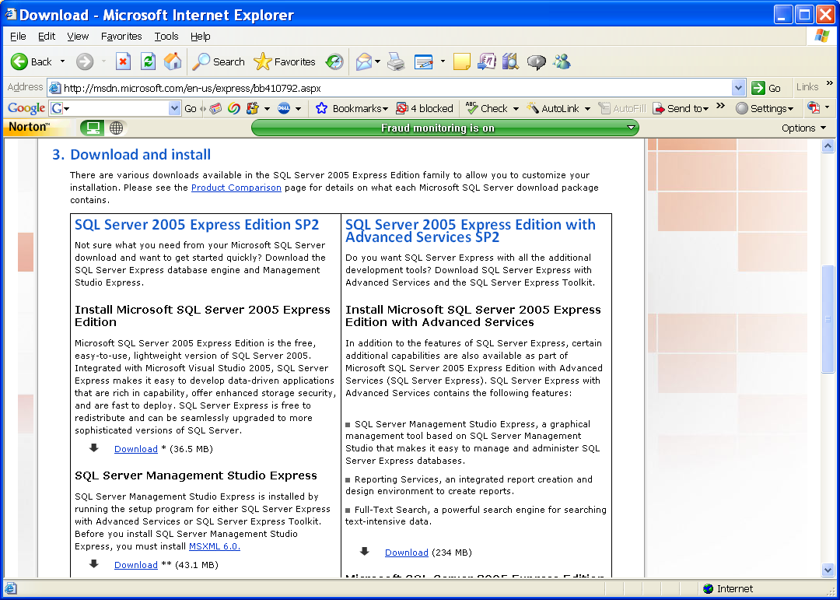
Click to download SQL Server 2005 EX
Click to download SQL Server Management Studio Express

When the download is done, open the Temp folder and double click the downloaded file SQLEXPR32.exe and click the Run button to install it.
Accept the license agreement and click the Next button to go to the Installation Prerequisite page to check and confirm that all required files have been installed in this computer. Follow the instructions and click the Next buttons to go to the installation page. Enter your name and organization name to complete the registration process, and go to the Feature Selection page, which is shown below.

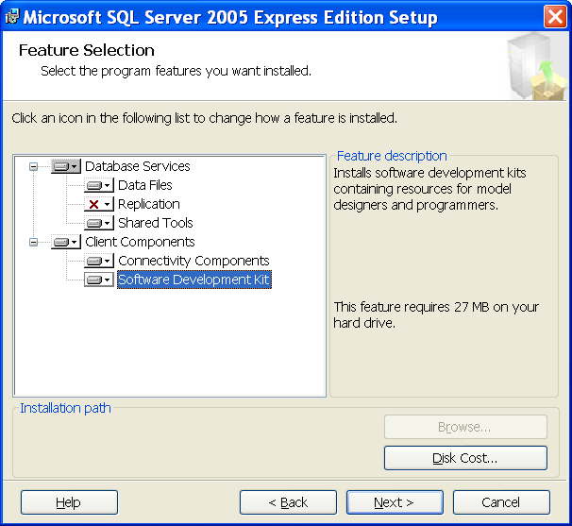

Make sure that the components you selected should match those displayed above. Click the Next to continue.
The next page is to allow you to select the instance name. We prefer to select the Named Instance since we may install SQL Server 2008 Express later. In order to distinguish with that, we use the SQLExpress5 as the name for this database instance, which is shown below.

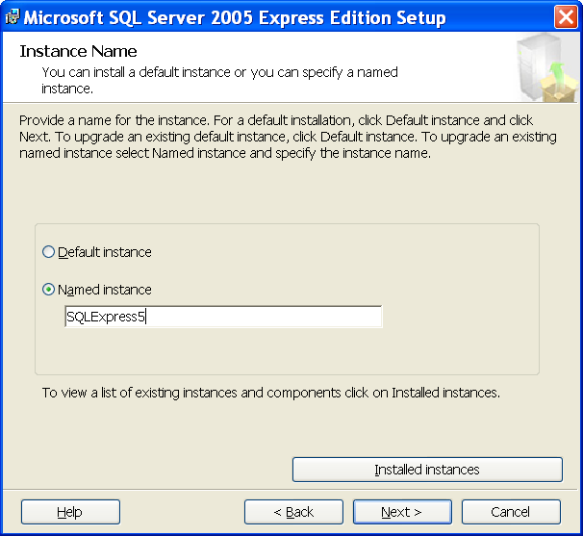
Click the Next button to go to the security authentication dialog.
Select the Windows authentication as the security mode and click the Next to go to the next page. Click the Next button for the next dialog since we want to keep this default Configuration Options.
In the Error and Usage Report page, check both checkboxes to allow the error and usage to be reported automatically. Click the Next and Install buttons to begin this installation.
When the installation is done, a summary of this installation is displayed and it is shown below. Click the Next, and then Finish buttons to close this installation.

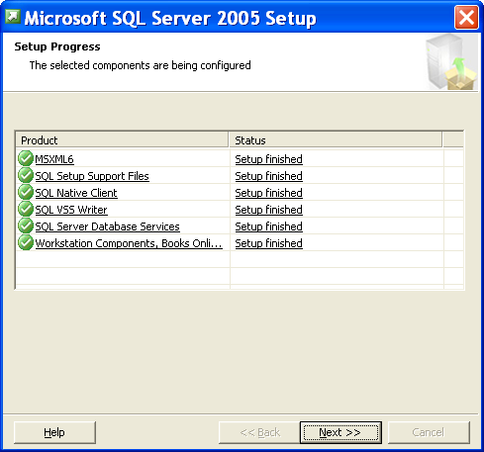

Next you need to download and install SQL Server Management Studio Express, which works as a graphic user interface and allows you to access SQL Server 2005 Express database engine. Return to the Download SQL Server 2005 Express page, and click the Download hyperlink that is under the section of SQL Server Management Studio Express.
Select the Save button to store this file into our Temp folder. When the download is finished, open our Temp folder and double click the downloaded file SQLServer2005_SSMSEE.msi and the Run button to run the installation file.
Follow the instructions on a sequence of dialogs such as accepting the license agreement and the registration process by entering your name and your organization name to complete this installation.
Finally click the Finish button to close this installation.

Click to download SQL Server Management Studio Express

- Configuration and Connection

When you finish the installation of SQL Server Management Studio Express, you need to configure it to connect with your SQL server when you start to use the SQL Server 2005 Database. Exactly, the above jobs you did are to install both SQL Server 2005 and SQL 2005 Client on your laptop computer, so your laptop contains both SQL server and SQL client. The purpose of doing this is to allow your guys to learn how to design and build a real database using the SQL Server, and to communicate with it by using a client.
To configure the Management Studio Express, go to Start|All Programs|Microsoft SQL Server 2005, and then select the SQL Server Management Studio Express. A connection dialog will be opened as shown below:

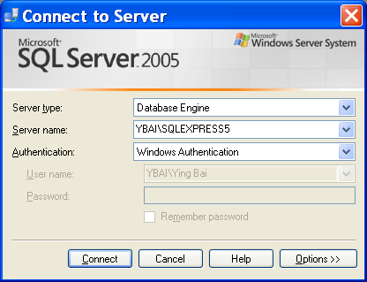

In the Server Name box, it should be your computer name followed by the SQL Server Express name, which should be YBAI\SQLEXPRESS5 since the YBAI is the computer name or the logon name and the SQLEXPRESS5 is the instance name of the SQL Server database. Select the Windows Authentication method from the Authentication box to use the Windows NT default security engine. Click the Connect button to connect your client with your server together.
After you setup a connection between your client and your SQL Server, you can create, access and manipulate the database in your server. Refer to section 2.10 in Chapter 2 to build the user-defined database in SQL Server 2005 environment.

Trouble Shooting To Install MS SQL Server 2005

- SQL Writer:
SQLDUMPER library failed initialization. Your installation is either corrupt or has been tampered with. Please uninstall then re-run setup to correct this problem.

SOLUTION:
Remove Microsoft SQL Server VSS Writer from the Control Panel by using the Add or Remove Program, and re-install SQL Server 2005 Express.

- An installation package for the product Microsoft SQL Server Native Client cannot be found. Try the installation again using a valid copy of the installation package "sqlncli.msi"

SOLUTION:
Remove Microsoft SQL Server Native Client from the Control Panel by using the Add or Remove Program, and re-install SQL Server 2005 Express.

- An installation package for the product Microsoft SQL Server VSS writer cannot be found. Try the installation again using a valid copy of the installation package "sqlwriter.msi"

SOLUTION:
Remove Microsoft SQL Server VSS Writer from the Control Panel by using the Add or Remove Program, and re-install SQL Server 2005 Express.

